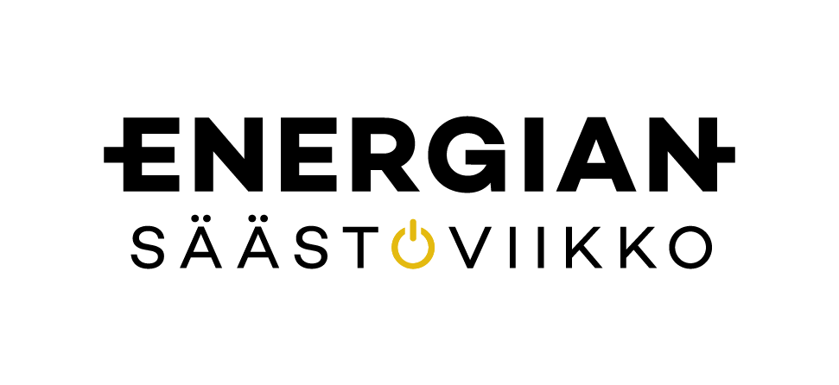

WE ARE SPENDING ENERGY
AWARENESS WEEK 11-17.10.2021.
WHAT ABOUT YOU?

WWW. ENERGIANSAASTOVIIKKO.FI

